GO!

⠀  
**G**et **O**rganized!

Produced By:

Seth Bedford, Katerin Flores, Sushith Ghanta  
Shrinath Rao, Christopher tePoele

# Final Project Draft Description

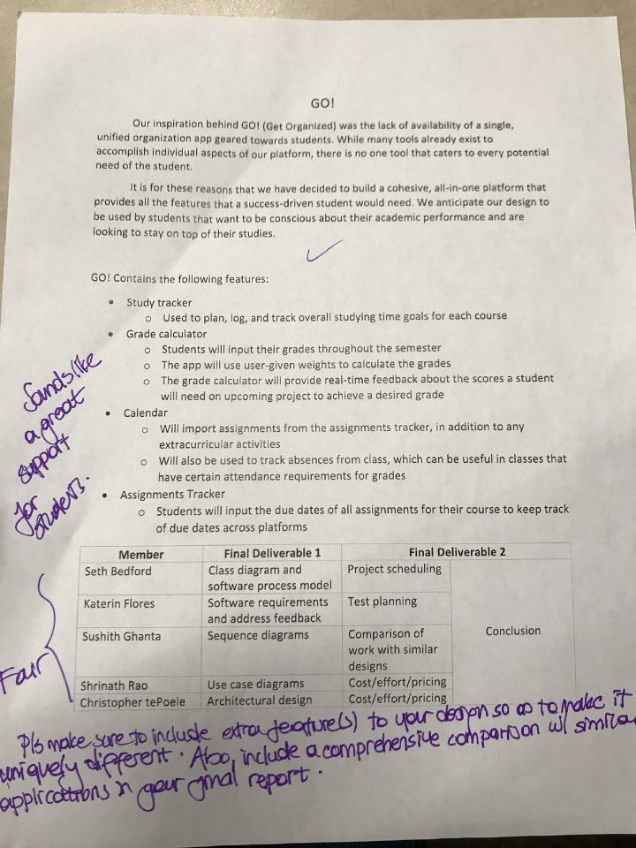

## Address Feedback:

To make our application more unique we decided to add file uploading features. When the user adds assignments they need to complete, they will be able to do more than specify the class and due date. The user will be able to upload the assignment specifications and any relevant sources or notes they will need to complete the assignment. This will allow the student to have all the necessary materials for each assignment accessible in one place and at their disposal regardless of their location or computer. The students will also be able to upload the syllabus to each individual class to have access to a convenient reference when needed.

# Setting Up a GitHub Repository:

## Team Members:

Seth Bedford - sethbedford

Shrinath Rao - shrinathrao97

Sushith Ghanta - sghanta

Katerin Flores - ksf-20

Christopher tePoele - CtePoele

## Task 1.3 Completed By:

Katerin Flores

## Task 1.4 Completed By:

Seth Bedford

## Task 1.5 Completed By:

Shrinath Rao

## Team Repository URL:

<https://github.com/ksf-20/3354-GO>

# Task Delegation:

|  |  |
| --- | --- |
| Member | Final Deliverable 1 |
| Seth Bedford | Class diagram and software process model |
| Katerin Flores | Software requirements and address feedback |
| Sushith Ghanta | Sequence diagrams |
| Shrinath Rao | Use case diagrams |
| Christopher tePoele | Architectural design |

# Employed Software Process Model:

Our project will employ the spiral model due its evolutionary approach. GO! is a very modular application – there are several separate feature sets within the one application. By using the spiral model, we can develop GO! modularly and prototype each feature along the way. This stepwise approach will allow us to assess risks relevant to each function of the project at each stage. This model also allows for changes to be made throughout the process. If we decide that another feature needs to be added or an existing feature needs to be modified or removed altogether, then the spiral model will provide us with that flexibility.

# Software Requirements:

## Functional Requirements:

1. The user should be able to add class courses.
2. The user should be able to log absences and request receipt of past absences.
3. The user should be able to request required scores for desired grade.
4. The user should be able to add assignments and attach related files.
5. The user should be able to log their study hours.
6. The system should generate a weekly overview of assignments due, studying progress and upcoming events.
7. The system should issue reminders of assignments and exams that will be due in 24 hours.
8. The system should issue warnings when absences will exceed class regulations.

## Non-functional Requirements:

1. (Product requirement) The GO! application should consistently update in real time the progress of the student, assignments due and activities that will occur within a 7-day period beginning on the present day.
2. (Organizational requirement) Users of the GO! application are required to sign-up with a school email to verify they qualify for free use of our service.
3. (External Requirements) The user’s email, class assignments, grades and any other information provided by the user needs to remain confidential to protect the user’s privacy.

# Case Diagrams:

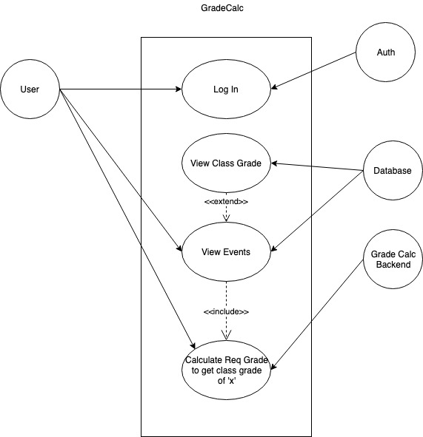 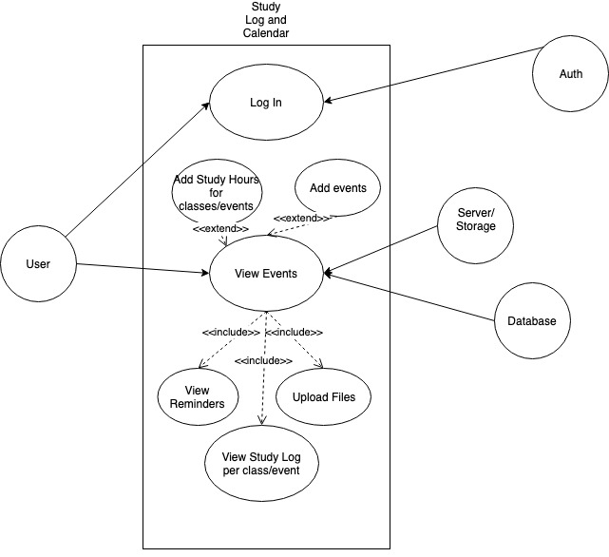

# Sequence Diagrams:

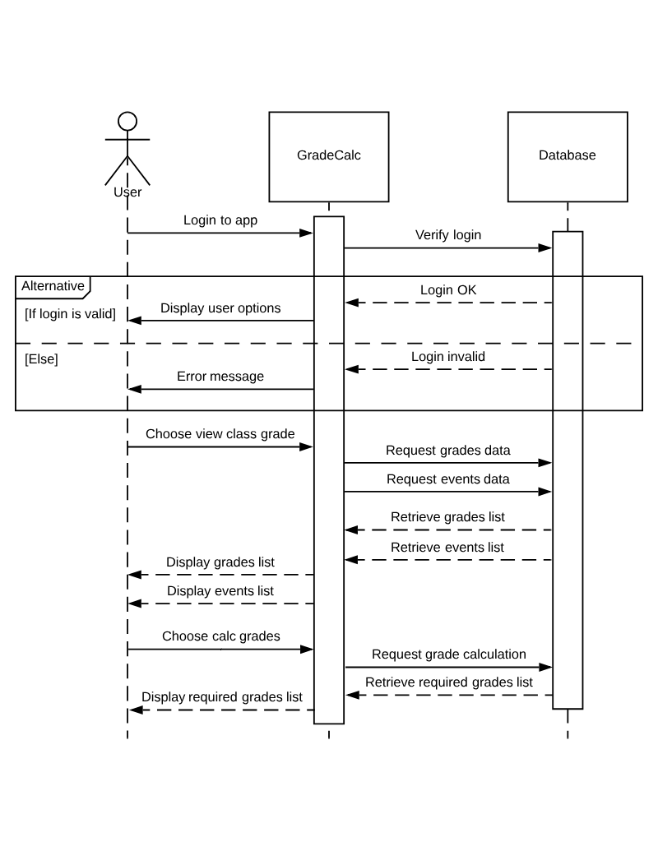

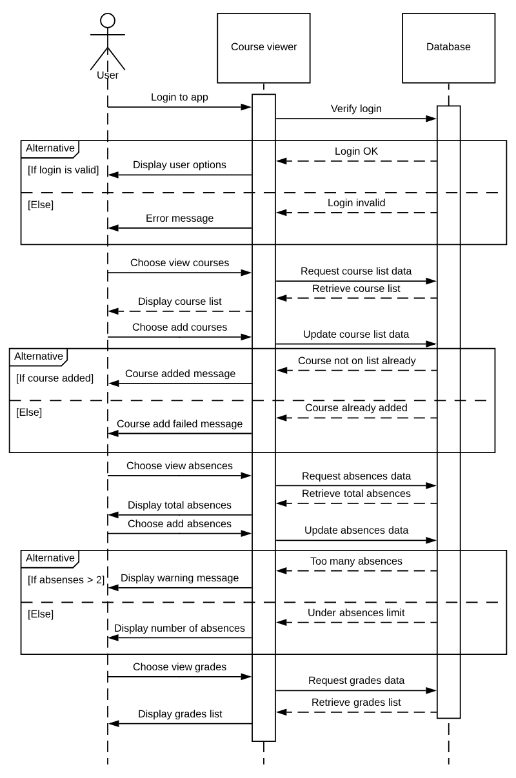 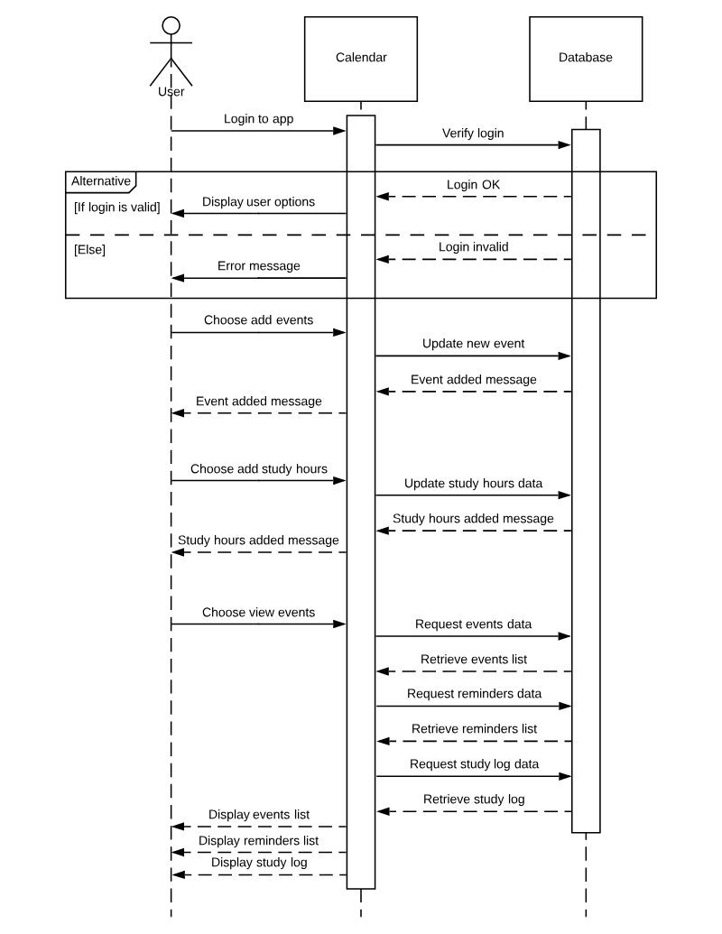

# Class Diagram:

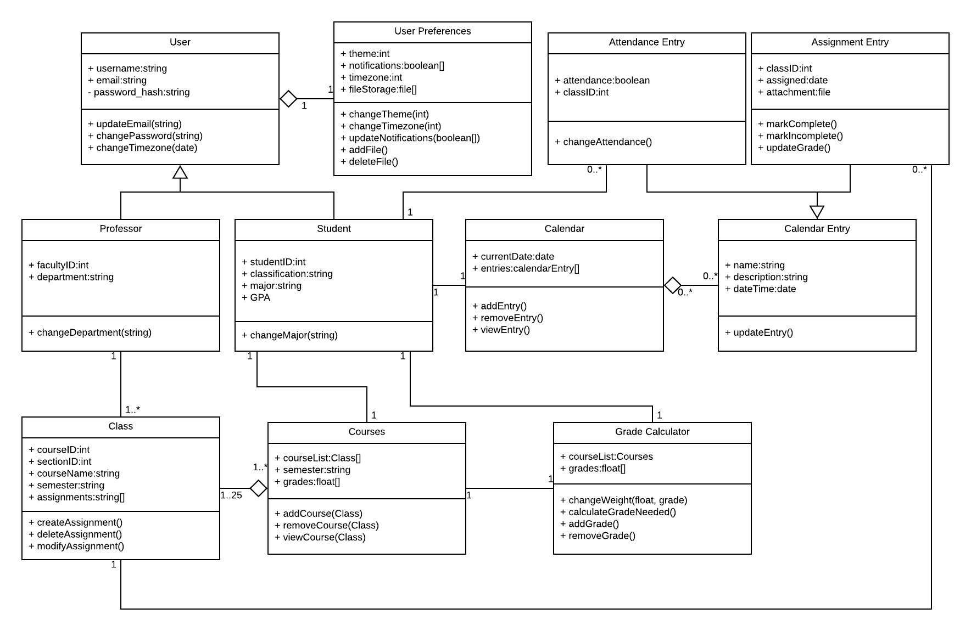

# Architectural Design – MVC:

